HW 2 Solutions

%divided differences

%F(i,i) are the coeffs of the Lagrange Poly

clear all

%data points given

node=[5 10 15 20];

n=15; %datax=linspace(-1,1,n); for i=1:n

datax(i)=cos((2\*i-1)\*pi/(2\*n)); end

datay=1./(1+25.\*datax.^2);

F = zeros(n,n);

for i = 1:n

F(i,1) = datay(i);

end

for i = 2:n

for j = 2:i

F(i,j) = (F(i,j-1)-F(i-1,j-1))/(datax(i)-datax(i-j+1)); num=(F(i,j-1)-F(i-1,j-1))  
denom=(datax(i)-datax(i-j+1))

end end

xnew=[-1:.01:1]; P=F(1,1); Lagrange=F(1,1); Product=1; ProductL=1;

syms x

for i=2:n

Product=Product.\*(xnew-datax(i-1));  
%Calculating P, lagrange poly for graphing P=P+F(i,i).\*Product;  
%Calculating Lagrange poly for integration purposes ProductL=ProductL.\*(x-datax(i-1)); Lagrange=Lagrange+F(i,i).\*ProductL;

end  
Lint=double(int(Lagrange,x,datax(1),datax(n)))

Fint=double(int(1/(1+25\*x^2),x,datax(1),datax(n)))

set(0,’defaultaxesfontsize’,24);

%could also plot Lagrange poly with symbolic notation using ezplot(P,[min %max])  
figure(1)  
plot(xnew,1./(1+25.\*xnew.^2),’-k’,’LineWidth’,3)

hold on  
plot(xnew,P,’-m’,’LineWidth’,3)  
hold on plot(datax,datay,’o’,’MarkerEdgeColor’,’k’,’MarkerFaceColor’,’b’,’MarkerSize’,10,’LineWidth’,2) hold on  
xlabel(‘x axis’,’FontWeight’,’bold’)  
ylabel(‘y axis’,’FontWeight’,’bold’)  
legend(‘Function’,’Lagrange’,’Data’)  
title(‘Chebyshev Nodes n=15’,’FontWeight’,’bold’)

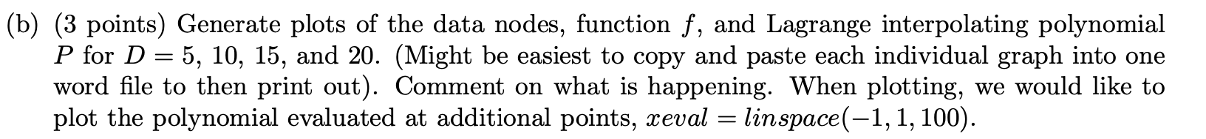

We can certainly see that the Lagrange interpolating polynomial is getting rather large in its oscillations towards the endpoints with higher degree polynomials (D=15 and 20 data points). Also, the interpolating polynomial is changing concavity more than the function even with D=5 data points; this is due to the fact that it is a 4th -degree polynomial with D=5 and the function that the data comes from is not a polynomial.

Can get these errors by running for each D, put them in a vector, and then graph using a simple bar command in matlab. (Or the code can be re-written to run over an additional loop with D=5, 10, 15, and 20)



